**Ace Decorative Playing Card Mirror**

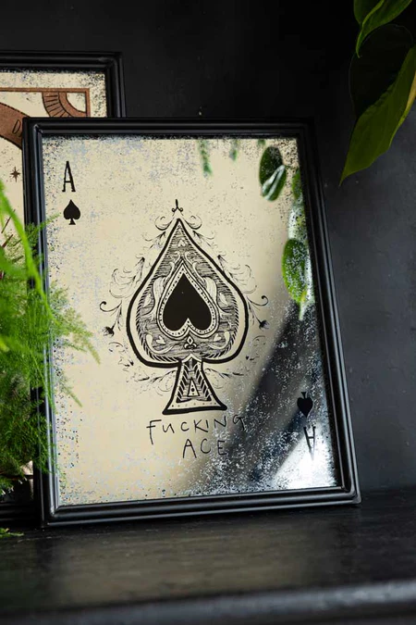Elevate your space with the **Ace Decorative Playing Card Mirror**. This unique mirror features a design inspired by classic playing cards, showcasing the Ace of Spades with striking details that bring a playful yet sophisticated flair to your décor. The frame is meticulously crafted to capture the essence of a vintage card deck, making it a perfect statement piece for game rooms, living rooms, or any area where you want to add a touch of personality. With its bold and creative design, this mirror combines fun and functionality, making it an ideal addition to any stylish home or entertainment space.